Exercise 8

- How many unique salary packages does our company, Bignet, Offer? List them in descending order.
SELECT DISTINCT count(salary) FROM `employee_data`;
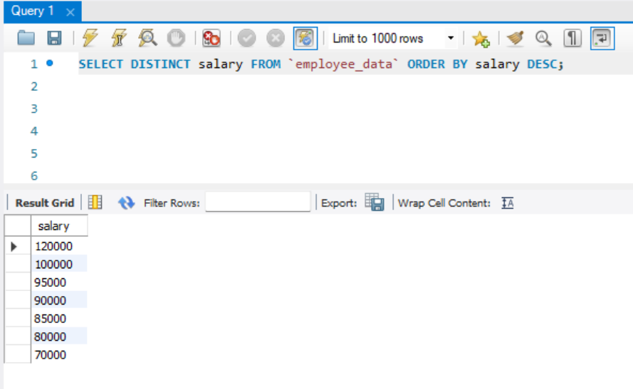
- How many District first names do we have in our database?
SELECT DISTINCT count(f_name) FROM `employee_data`;
